Summer Internship Report
on

EMAIL SPAM DETECTION USING MACHINE LEARNING

Submitted in partial fulfillment of the Requirement for the award of the degree of

Bachelor of Engineering
in
Computer Science and Engineering

by

VIJAYALAXMI BIRADAR 1608-21-733-312

Under the guidance of

M. Dattatreya Goud

Director of Dcode soft tech solutions Pvt Ltd



Department of Computer Science and Engineering
MATRUSRI ENGINEERING COLLEGE
SAIDABAD – 500 059

FEBRUARY 2025

mATRUSRI ENGINEERING COLLEGE
SAIDABAD - 500059



Department of Computer Science and Engineering

Certificate

This is to certify that the internship report entitled “Email Spam Detection using Machine Learning Algorithms” submitted by Ms. Vijayalaxmi Biradar bearing H.T. No: 1608-21-733-312 , in the partial fulfillment of the requirement for the award of the degree of Bachelor of Engineering in Computer Science and Engineering is a bonafide work carried by her.
The results of the investigations enclosed in this report have been verified and found satisfactory.

Internal Supervisor HOD
Dept. of CSE Dept. of CSE
MECS. MECS.

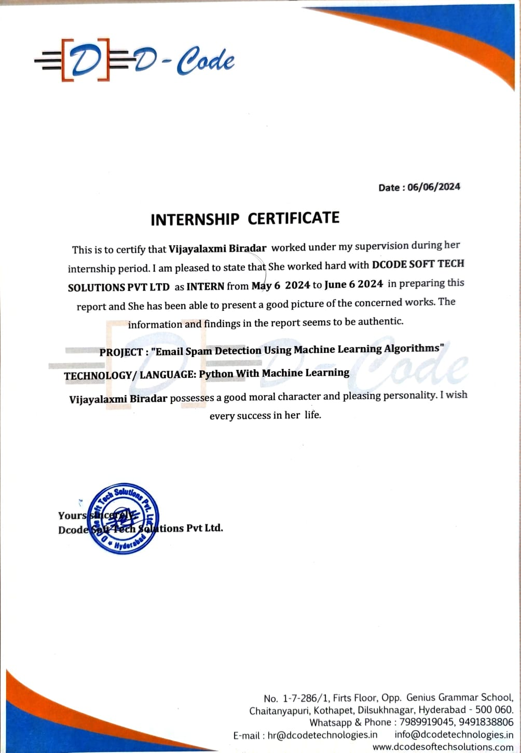
ACKNOWLEDGEMENT

We would like to express our sincere gratitude and appreciation to all the individuals and organizations who have contributed to the successful completion of this project. “Email Spam Detection using Machine Learning Algorithms”.

First and foremost, we would like to extend our heartfelt thanks to M Dattatreya Goud whose guidance, expertise, and support were invaluable throughout the entire duration of this project. He provided us with valuable insights, feedback, and direction, helping us navigate through challenges and make informed decisions. He played a significant role in shaping our ideas and ensuring the project's smooth progress.

We are grateful to Dr. T. Raghunadha Reddy, Head of Department, Computer Science and Engineering, Matrusri Engineering College, Hyderabad, for providing us with this internship opportunity. It has given us valuable exposure to working in an industrial environment and has contributed significantly to our learning and professional development.

We are also indebted to our project team members for their hard work, dedication, and collaborative efforts. Each team member contributed their unique skills and perspectives, working tirelessly to design, develop, and implement the web portal. The success of this project is a testament to their exceptional teamwork and commitment.

ABSTRACT

Email Spam has become a major problem nowadays, with Rapid growth of internet users, Email spams is also increasing. People are using them for illegal and unethical conducts, phishing and fraud. Sending malicious link through spam emails which can harm our system and can also seek in into your system. Creating a fake profile and email account is much easy for the spammers, they pretend like a genuine person in their spam emails, these spammers target those peoples who are not aware about these frauds. So, it is needed to Identify those spam mails which are fraud, this project will identify those spam by using techniques of machine learning, this paper will discuss the machine learning algorithms and apply all these algorithm on our data sets and best algorithm is selected for the email spam detection having best precision and accuracy .
This project focuses on building a machine learning model for detecting spam emails using the Multinomial Naive Bayes algorithm. The dataset consists of labeled email texts, classified as spam or non-spam. The raw text data is preprocessed using TF-IDF vectorization to convert it into numerical form suitable for machine learning. The dataset is split into training and testing sets using an 80-20 split. The Multinomial Naive Bayes classifier is trained on the TF-IDF features to predict whether an email is spam or not. The performance of the model is evaluated using accuracy, confusion matrix, and a classification report. The final model and vectorizer are serialized using pickle for future use. Results indicate that the model achieves high accuracy in classifying spam emails, making it a reliable tool for spam detection.

CONTENTS

Chapter-1 INTRODUCTION .......................................................................................8
  - LITERATURE SURVEY ...........................................................................8
  - EXISTING SYSTEM……………………………………………………..9
  - PROPOSED SYSTEM……………………………………………………9
  - HARDWARE AND SOFTWARE REQ………………………………….10
  - PROBLEM STATEMENT ……………………………………………….10

Chapter-2 BACKGROUND KNOWLEDGE…………………………………………11
2.1 MACHINE LEARNING FOR TEXT CLASSIFICATION………………11
2.2 TECHNIQUES AND TOOLS ……………………………………………11
2.3 FLASK WEB APPLICATION……………………………………….…...12
2.4 SERIALIZATION………………………….……………………………...12
2.5 VISUALIZATION………………………….……………………………..12
2.6 PERFORMANCE METRICS ……………….……………………………12

Chapter-3 OBJECTIVES AND GOALS ......................................................................13
3.1 OBJECTICES
3.2 GOALS

Chapter-4 TECHNOLOGY STACK/ SKILLS
ACCQUIRED/ DEVELOPED
4.1 TECHNOLOGY STACK………………………………………………....14
4.2 SKILLS ACQUIRED/DEVELOPED…………………………………….20

Chapter-5 ACHIEVEMENTS AND CONTRIBUTIONS………………………..…..21
5.1 ACHIEVEMENTS
5.2 PERSONAL CONTRIBUTIONS

Chapter-6 PROCESS/METHODOLOGY OF PROJECT
6.1 SYSTEM ARCHITECTURE………………………………..…………..23
6.2 SYSTEM DESIGN…………………………………………..…………..24
6.3 METHODOLOGY……………………………………………..………..27
6.4 IMPLEMENTAION……………………………………………..………28

Chapter-7 RESULT SCREENS………………………………………………..…….29

Chapter-8 FUTURE APPLICATION………..………………………………………31

Chapter-9 CONCLUSION……………………..…………………………………….33
LIST OF FIGURES

S.NO | NAME OF FIGURE | PAGE NO.
6.1 | SYSTEM ARCHITECTURE | 23
6.2 | USE CASE DIAGRAM | 25
6.3 | CLASS DIAGRAM | 25
6.4 | SEQUENCE DIAGRAM | 26
6.5 | COLLABORATION DIAGRAM | 26
7.1 | HOME PAGE | 29
7.2 | LOGIN PAGE | 29
7.3 | UPLOAD PAGE | 30
7.4 | PREDICTION PAGE | 30

CHAPTER – 1
INTRODUCTION:

Email or electronic mail spam refers to the “using of email to send unsolicited emails or advertising emails to a group of recipients. Unsolicited emails mean the recipient has not granted permission for receiving those emails. “The popularity of using spam emails is increasing since last decade. Spam has become a big misfortune on the internet. Spam is a waste of storage, time and message speed. Automatic email filtering may be the most effective method of detecting spam but nowadays spammers can easily bypass all these spam filtering applications easily. Several years ago, most of the spam can be blocked manually coming from certain email addresses. Machine learning approach will be used for spam detection. Major approaches adopted closer to junk mail filtering encompass “text analysis, white and blacklists of domain names, and community-primarily based techniques”. Text assessment of contents of mails is an extensively used method to the spams. Many answers deployable on server and purchaser aspects are available. Naive Bayes is one of the utmost well-known algorithms applied in these procedures. However, rejecting sends essentially dependent on content examination can be a difficult issue in the event of bogus positives. Regularly clients and organizations would not need any legitimate messages to be lost. The boycott approach has been probably the soonest technique pursued for the separating of spams. The technique is to acknowledge all the sends other than those from the area/electronic mail ids. Expressly boycotted. With more up to date areas coming into the classification of spamming space names this technique keeps an eye on no longer work so well. The white list approach is the approach of accepting the mails from the domain names/addresses openly whitelisted and place others in a much less importance queue, that is delivered most effectively after the sender responds to an affirmation request sent through the “junk mail filtering system”

1.1 LITERATURE SURVEY:
A Comprehensive Survey for Intelligent Spam Email Detection.
AUTHOR: Karim A., Azam S., Shanmugam B., Krishnan K., & Alazab M.
Abstract:
The tremendously growing problem of phishing e-mail, also known as spam including spear phishing or spam borne malware, has demanded a need for reliable intelligent anti-spam e-mail filters. This survey paper describes a focused literature survey of Artificial Intelligence (AI) and Machine Learning (ML) methods for intelligent spam email detection, which we believe can help in developing appropriate countermeasures. In this paper, we considered 4 parts in the email's structure that can be used for intelligent analysis: (A) Headers Provide Routing Information, contain mail transfer agents (MTA) that provide information like email and IP address of each sender and recipient of where the email originated and what stopovers, and final destination. (B) The SMTP Envelope, containing mail exchangers' identification, originating source and destination domains\users. (C) First part of SMTP Data, containing information like from, to, date, subject - appearing in most email clients (D) Second part of SMTP Data, containing email body including text content, and attachment. Based on the number the relevance of an emerging intelligent method, papers representing each method were identified, read, and summarized. Insightful findings, challenges and research problems are disclosed in this paper. This comprehensive survey paves the way for future research endeavors addressing theoretical and empirical aspects related to intelligent spam email detection

1.2 EXISTING SYSTEM :
Tokenization is the process of splitting a stream of manuscript into phrase, symbols, words, or any expressive elements named as tokens.” The rundown of token further utilized for contribution for additional handling, for example, content mining and parsing. Tokenization is valuable in both semantics (where it is as content division), and as lexical examination in software engineering and building. It is occasionally hard to define what is intended by the term “word”. As tokenization happens at the word level. Frequently a token trusts on modest heuristics, for instance: Tokens are parted by whitespaces characters, like “line break” or “space”, or by “punctuation characters”. Every single neighboring string of alphabetic characters are a piece of one token; similarly, with numbers. White spaces and punctuations might or might not involve in the resulting lists of tokens

DISADVANTAGES OF EXISTING SYSTEM :
1) Less accuracy
2)low Efficiency

1.3 PROPOSED SYSTEM :
When the data is considered, always a very large data sets with large no. of rows and columns will be noted. But it is not always the case the data could be in many forms such as Images, Audio and Video files Structured tables etc. Machine doesn’t understand images or video, text data as it is, Machine only understand 1s and 0s. Steps in Data Preprocessing: Data cleaning: In this step the work like filling of “missing values”, “smoothing of noisy data”, “identifying or removing outliers “, and “resolving of inconsistencies is done.” Data Integration: In this step addition of several databases, information files or information set is performed. Data transformation: Aggregation and normalization is performed to scale to a specific value Data reduction: This section obtains a summary of the dataset which is very

ADVANTAGES OF PROPOSED SYSTEM :
1) High accuracy
2)High efficiency

1.4 HARDWARE & SOFTWARE REQUIREMENTS:
HARDWARE REQUIRMENTS :
- System : i3 or above.
- Ram : 4 GB.
- Hard Disk : 40 GB
SOFTWARE REQUIRMENTS :
- Operating system : Windows8 or Above.
- Coding Language : python

1.5 Problem Statement
With the increasing volume of digital communication, spam emails have become a significant challenge for individuals and organizations. Spam emails, which typically include unsolicited advertisements, phishing attempts, malware, or other malicious content, not only disrupt productivity but also pose security risks. The sheer volume of spam messages received on a daily basis makes it difficult for traditional rule-based filtering systems to efficiently identify and block spam. Moreover, spammers continuously evolve their tactics to bypass these filters, making it essential for spam detection systems to be dynamic, adaptive, and capable of handling the complexities of modern email communication.
The problem is that existing spam detection systems often struggle to accurately classify new or evolving spam messages. This results in either false positives (non-spam messages incorrectly classified as spam) or false negatives (spam messages not detected). There is a clear need for a robust, scalable, and efficient system that can accurately classify emails as either spam or non-spam based on their content, reducing manual effort and minimizing the risk of users missing important messages or falling victim to fraudulent activities.

CHAPTER - 2
BACKGROUND KNOWLEDGE

2.1 Machine Learning for Text Classification
In this project, the goal is to classify email messages as spam or non-spam. This is a binary classification problem where machine learning models can learn patterns in text data to make predictions.
- Spam emails: Unwanted emails, often containing advertising, scams, or malicious links.
- Non-spam (ham) emails: Legitimate messages from known or trusted sources.
The workflow of text classification involves several key steps:
- Data Preprocessing – Converting raw text into a format that the model can understand.
- Feature Extraction – Representing text numerically using TF-IDF (Term Frequency-Inverse Document Frequency) to capture the importance of words.
- Model Training – Training a Multinomial Naive Bayes classifier on the extracted features.
- Evaluation and Deployment – Measuring the model’s performance using accuracy, confusion matrix, and then deploying it in a Flask web app.

2.2 Techniques and Tools Used
- Python Libraries
  - pandas: For reading and manipulating CSV data files.
  - scikit-learn: Machine learning library for building and evaluating the classifier.
  - Flask: Micro web framework to create a web application for user interaction.
  - pickle: For saving and loading the trained model and vectorizer for fast predictions.
- Feature Extraction: TF-IDF
  - TF-IDF transforms the text into numerical features by evaluating how important a word is within the document and across all documents.
  - TF (Term Frequency): Counts how often a term appears in a document.
  - IDF (Inverse Document Frequency): Reduces the importance of common words that appear in most documents.
- Multinomial Naive Bayes (MNB) Classifier
  - This algorithm is well-suited for text classification.
  - It assumes the features (words) are conditionally independent and calculates probabilities for each class (spam or non-spam).
  - Despite its simplicity, it’s highly effective for text-based tasks.

2.3 Flask Web Application
The application has several routes and views:
- Home (/): Displays the homepage.
- Login (/login): Dummy login page.
- Abstract (/abstract): Shows the project abstract.
- Future Work (/future): Discusses potential future improvements.
- User (/user): User-specific page.
- Upload Dataset (/upload): Allows the user to upload a CSV file.
- Preview Dataset (/preview): Displays the first few rows of the uploaded dataset.
- Prediction (/prediction): Takes user input (text) and predicts whether it’s spam or not.
- Performance (/performance): Displays model performance details (accuracy, confusion matrix, etc.).

2.4 Serialization and Model Deployment
- The trained TF-IDF vectorizer and Naive Bayes model are saved using pickle. This allows you to avoid re-training the model every time the server restarts.
- These files (tranform.pickle and model.pickle) are loaded in the Flask app and used for real-time predictions.

2.5 Visualization
The application can include:
- Confusion Matrix Heatmap: Visual representation of how well the model distinguishes spam from non-spam.
- Prediction Result Display: Showing the prediction (Spam or No Spam) clearly on the result page.

2.6 Performance Metrics
To evaluate the model:
- Accuracy – Percentage of correct predictions.
- Precision, Recall, F1-Score – More detailed metrics, especially useful for imbalanced datasets.
- Confusion Matrix – Visualizes true positives, false positives, true negatives, and false negatives.

CHAPTER – 3
INTERNSHIP OBJECTIVES AND GOALS

3.1 Internship Objectives
- Practical Application of Machine Learning Concepts
  - Gain hands-on experience in developing machine learning models for real-world text classification problems.
  - Understand and apply advanced techniques like TF-IDF Vectorization and Naive Bayes Classifier for spam detection.
- Full-stack Project Development
  - Build an end-to-end application by integrating machine learning models with a Flask-based web interface.
  - Develop skills in frontend technologies (HTML, CSS, Bootstrap) and backend development using Flask.
- Data Handling and Preprocessing
  - Learn effective methods for data cleaning, preprocessing, and feature engineering.
  - Work with large datasets and extract meaningful insights using pandas and NumPy.
- Model Deployment and Performance Evaluation
  - Deploy machine learning models in a web application for real-time prediction.
  - Evaluate model performance using metrics like accuracy, confusion matrix, and F1-score.
- Collaboration and Communication
  - Work collaboratively in a team environment to divide tasks and achieve project milestones.
  - Improve communication skills by presenting project results and writing comprehensive documentation.

3.2 Internship Goals
- Develop a Functional Spam Detection System that can accurately classify emails as spam or non-spam.
- Acquire Proficiency in Machine Learning and Web Development, focusing on model integration with web-based interfaces.
- Build Strong Data Analysis Skills to handle and analyze large datasets efficiently.
- Explore Advanced Deployment Techniques for hosting the project on cloud services like Heroku or AWS.
- Improve Problem-solving and Critical Thinking Abilities by overcoming challenges in model accuracy, web app design, and deployment.
CHAPTER – 4
TECHNOLOGY STACK/SKILLS REQUIRED

4.1 Technology Stack

Programming Language
Python
Python is an interpreted high-level programming language for general-purpose programming. Created by Guido van Rossum and first released in 1991, Python has a design philosophy that emphasizes code readability, notably using significant whitespace.
Python features a dynamic type system and automatic memory management. It supports multiple programming paradigms, including object-oriented, imperative, functional and procedural, and has a large and comprehensive standard library.
Python is Interpreted − Python is processed at runtime by the interpreter. You do not need to compile your program before executing it. This is similar to PERL and PHP.
Python is Interactive − you can actually sit at a Python prompt and interact with the interpreter directly to write your programs.
Python also acknowledges that speed of development is important. Readable and terse code is part of this, and so is access to powerful constructs that avoid tedious repetition of code. Maintainability also ties into this may be an all but useless metric, but it does say something about how much code you have to scan, read and/or understand to troubleshoot problems or tweak behaviors. This speed of development, the ease with which a programmer of other languages can pick up basic Python skills and the huge standard library is key to another area where Python excels. All its tools have been quick to implement, saved a lot of time, and several of them have later been patched and updated by people with no Python background - without breaking.
The biggest strength of Python is huge collection of standard library which can be used for the following –
  - Machine Learning
  - GUI Applications (like Kivy, Tkinter, PyQt etc. )
  - Web frameworks like Django (used by YouTube, Instagram, Dropbox)
  - Image processing (like Opencv, Pillow)
  - Web scraping (like Scrapy, BeautifulSoup, Selenium)
  - Test frameworks
  - Multimedia

Advantages of Python :-
Let’s see how Python dominates over other languages.

1. Extensive Libraries
Python downloads with an extensive library and it contain code for various purposes like regular expressions, documentation-generation, unit-testing, web browsers, threading, databases, CGI, email, image manipulation, and more. So, we don’t have to write the complete code for that manually.

2. Extensible
As we have seen earlier, Python can be extended to other languages. You can write some of your code in languages like C++ or C. This comes in handy, especially in projects.

3. Embeddable
Complimentary to extensibility, Python is embeddable as well. You can put your Python code in your source code of a different language, like C++. This lets us add scripting capabilities to our code in the other language.

4. Improved Productivity
The language’s simplicity and extensive libraries render programmers more productive than languages like Java and C++ do. Also, the fact that you need to write less and get more things done.

5. IOT Opportunities
Since Python forms the basis of new platforms like Raspberry Pi, it finds the future bright for the Internet Of Things. This is a way to connect the language with the real world.
When working with Java, you may have to create a class to print ‘Hello World’. But in Python, just a print statement will do. It is also quite easy to learn, understand, and code. This is why when people pick up Python, they have a hard time adjusting to other more verbose languages like Java.

7. Readable
Because it is not such a verbose language, reading Python is much like reading English. This is the reason why it is so easy to learn, understand, and code. It also does not need curly braces to define blocks, and indentation is mandatory. This further aids the readability of the code.

8. Object-Oriented
This language supports both the procedural and object-oriented programming paradigms. While functions help us with code reusability, classes and objects let us model the real world. A class allows the encapsulation of data and functions into one.

9. Free and Open-Source
Like we said earlier, Python is freely available. But not only can you download Python for free, but you can also download its source code, make changes to it, and even distribute it. It downloads with an extensive collection of libraries to help you with your tasks.

10. Portable
When you code your project in a language like C++, you may need to make some changes to it if you want to run it on another platform. But it isn’t the same with Python. Here, you need to code only once, and you can run it anywhere. This is called Write Once Run Anywhere (WORA). However, you need to be careful enough not to include any system-dependent features.

11. Interpreted
Lastly, we will say that it is an interpreted language. Since statements are executed one by one, debugging is easier than in compiled languages..

Machine Learning & Data Processing

Machine Learning : -

Before we take a look at the details of various machine learning methods, let's start by looking at what machine learning is, and what it isn't. Machine learning is often categorized as a subfield of artificial intelligence, but I find that categorization can often be misleading at first brush. The study of machine learning certainly arose from research in this context, but in the data science application of machine learning methods, it's more helpful to think of machine learning as a means of building models of data.
Fundamentally, machine learning involves building mathematical models to help understand data. "Learning" enters the fray when we give these models tunable parameters that can be adapted to observed data; in this way the program can be considered to be "learning" from the data. Once these models have been fit to previously seen data, they can be used to predict and understand aspects of newly observed data. I'll leave to the reader the more philosophical digression regarding the extent to which this type of mathematical, model-based "learning" is similar to the "learning" exhibited by the human brain.Understanding the problem setting in machine learning is essential to using these tools effectively, and so we will start with some broad categorizations of the types of approaches we'll discuss here.

Categories Of Machine Leaning :-
At the most fundamental level, machine learning can be categorized into two main types: supervised learning and unsupervised learning.
Supervised learning involves somehow modeling the relationship between measured features of data and some label associated with the data; once this model is determined, it can be used to apply labels to new, unknown data. This is further subdivided into classification tasks and regression tasks: in classification, the labels are discrete categories, while in regression, the labels are continuous quantities. We will see examples of both types of supervised learning in the following section.
Unsupervised learning involves modeling the features of a dataset without reference to any label, and is often described as "letting the dataset speak for itself." These models include tasks such as clustering and dimensionality reduction. Clustering algorithms identify distinct groups of data, while dimensionality reduction algorithms search for more succinct representations of the data. We will see examples of both types of unsupervised learning in the following section.

Need for Machine Learning
Human beings, at this moment, are the most intelligent and advanced species on earth because they can think, evaluate and solve complex problems. On the other side, AI is still in its initial stage and haven’t surpassed human intelligence in many aspects. Then the question is that what is the need to make machine learn? The most suitable reason for doing this is, “to make decisions, based on data, with efficiency and scale”.
Lately, organizations are investing heavily in newer technologies like Artificial Intelligence, Machine Learning and Deep Learning to get the key information from data to perform several real-world tasks and solve problems. We can call it data-driven decisions taken by machines, particularly to automate the process. These data-driven decisions can be used, instead of using programing logic, in the problems that cannot be programmed inherently. The fact is that we can’t do without human intelligence, but other aspect is that we all need to solve real-world problems with efficiency at a huge scale. That is why the need for machine learning arises.

Challenges in Machines Learning :-
While Machine Learning is rapidly evolving, making significant strides with cybersecurity and autonomous cars, this segment of AI as whole still has a long way to go. The reason behind is that ML has not been able to overcome number of challenges. The challenges that ML is facing currently are −
Quality of data − Having good-quality data for ML algorithms is one of the biggest challenges. Use of low-quality data leads to the problems related to data preprocessing and feature extraction.
Time-Consuming task − Another challenge faced by ML models is the consumption of time especially for data acquisition, feature extraction and retrieval.
Lack of specialist persons − As ML technology is still in its infancy stage, availability of expert resources is a tough job.
No clear objective for formulating business problems − Having no clear objective and well-defined goal for business problems is another key challenge for ML because this technology is not that mature yet.
Issue of overfitting & underfitting − If the model is overfitting or underfitting, it cannot be represented well for the problem.
Curse of dimensionality − Another challenge ML model faces is too many features of data points. This can be a real hindrance.
Difficulty in deployment − Complexity of the ML model makes it quite difficult to be deployed in real life.

Applications of Machines Learning :-
Machine Learning is the most rapidly growing technology and according to researchers we are in the golden year of AI and ML. It is used to solve many real-world complex problems which cannot be solved with traditional approach. Following are some real-world applications of ML −
- Emotion analysis
- Sentiment analysis
- Error detection and prevention
- Weather forecasting and prediction
- Stock market analysis and forecasting
- Speech synthesis
- Speech recognition
- Customer segmentation
- Object recognition
- Fraud detection
- Fraud prevention
- Recommendation of products to customer in online shopping
Modules Used in Project :-
Tensorflow
TensorFlow is a free and open-source software library for dataflow and differentiable programming across a range of tasks. It is a symbolic math library, and is also used for machine learning applications such as neural networks. It is used for both research and production at Google.‍
TensorFlow was developed by the Google Brain team for internal Google use. It was released under the Apache 2.0 open-source license on November 9, 2015.
Numpy
Numpy is a general-purpose array-processing package. It provides a high-performance multidimensional array object, and tools for working with these arrays.
It is the fundamental package for scientific computing with Python. It contains various features including these important ones:
- A powerful N-dimensional array object
- Sophisticated (broadcasting) functions
- Tools for integrating C/C++ and Fortran code
- Useful linear algebra, Fourier transform, and random number capabilities
Besides its obvious scientific uses, Numpy can also be used as an efficient multi-dimensional container of generic data. Arbitrary data-types can be defined using Numpy which allows Numpy to seamlessly and speedily integrate with a wide variety of databases.
Pandas
Pandas is an open-source Python Library providing high-performance data manipulation and analysis tool using its powerful data structures. Python was majorly used for data munging and preparation. It had very little contribution towards data analysis. Pandas solved this problem. Using Pandas, we can accomplish five typical steps in the processing and analysis of data, regardless of the origin of data load, prepare, manipulate, model, and analyze. Python with Pandas is used in a wide range of fields including academic and commercial domains including finance, economics, Statistics, analytics, etc.
Matplotlib
Matplotlib is a Python 2D plotting library which produces publication quality figures in a variety of hardcopy formats and interactive environments across platforms. Matplotlib can be used in Python scripts, the Python and IPython shells, the Jupyter Notebook, web application servers, and four graphical user interface toolkits. Matplotlib tries to make easy things easy and hard things possible. You can generate plots, histograms, power spectra, bar charts, error charts, scatter plots, etc., with just a few lines of code. For examples, see the sample plots and thumbnail gallery.
For simple plotting the pyplot module provides a MATLAB-like interface, particularly when combined with IPython. For the power user, you have full control of line styles, font properties, axes properties, etc, via an object oriented interface or via a set of functions familiar to MATLAB users.
Scikit – learn
Scikit-learn provides a range of supervised and unsupervised learning algorithms via a consistent interface in Python. It is licensed under a permissive simplified BSD license and is distributed under many Linux distributions, encouraging academic and commercial use.

Feature Engineering
- TF-IDF Vectorization: To convert text data into numerical vectors for model training.

Web Framework
- Flask: To develop and deploy the web application.
  - Routing (@app.route) for different pages (e.g., prediction, upload, performance).
  - Integration of HTML templates for UI.
  - Handling HTTP requests (POST for file upload and prediction).

Model Serialization
- pickle: For saving and loading the trained machine learning model and vectorizer.
- joblib: Alternative for saving large models efficiently.

Frontend Technologies
- HTML/CSS/Bootstrap: For creating responsive web pages.
- Jinja2 (Flask’s Templating Engine): For dynamic content rendering in HTML.

Tools and IDEs
- Jupyter Notebook / VS Code: For coding and debugging the Python scripts.
- Postman (optional): For testing API endpoints of the Flask app.
- Git/GitHub: For version control and project collaboration.

4.2 Skills Required
- Python Programming: Strong foundation in Python syntax and libraries.
- Machine Learning Fundamentals: Understanding classification algorithms and evaluation metrics.
- Data Preprocessing and Cleaning: Handling missing values and preparing text data.
- Web Development Basics: Knowledge of Flask framework and how to build web-based services.
- Model Deployment: Skills in integrating machine learning models with web applications.

CHAPTER – 5
ACHIEVEMENTS AND CONTRIBUTIONS

5.1 Achievements
- Successful Spam Detection Model Implementation
  - Built a robust Multinomial Naive Bayes model with a high accuracy rate for detecting spam emails.
  - Optimized the model using TF-IDF Vectorization, resulting in improved prediction accuracy.
- Integration of Machine Learning Model with Web Interface
  - Developed a user-friendly web application using Flask for real-time spam detection.
  - Enabled users to upload email datasets and preview predictions directly through the web interface.
- Automation and Serialization
  - Used pickle to serialize the machine learning model and vectorizer for fast and efficient predictions without retraining the model.
- Performance Evaluation and Visualization
  - Implemented a comprehensive evaluation of the model using confusion matrix, classification report, and visualization through Seaborn and Matplotlib.
  - Achieved significant improvements in accuracy, precision, recall, and F1-score.
- Dynamic Dataset Preview Feature
  - Integrated a preview feature for uploaded datasets, enhancing the application's usability for large datasets.

5.2 Contributions
- Model Development and Optimization
  - Researched and selected the Multinomial Naive Bayes algorithm as the best fit for text classification tasks.
  - Preprocessed the dataset to remove missing values and tokenize the text data using TF-IDF.
- Web Application Development
  - Designed and implemented the frontend using HTML, CSS, and Jinja2 templates for a responsive UI.
  - Integrated multiple routes for features like prediction, dataset upload, and performance analysis.
- Documentation and Abstract Creation
  - Documented the complete project workflow, including background knowledge, technology stack, and future improvements.
- Team Collaboration and Knowledge Sharing (if applicable)
  - Collaborated with team members to divide tasks and ensure timely project completion.
  - Shared knowledge on Flask and machine learning concepts with peers.
- End-to-End Project Deployment
  - Ensured smooth deployment and real-time prediction capabilities through the web app.
  - Tested and validated the model’s performance across multiple test cases.

CHAPTER -6
PROCESS/METHODOLOGY OF PROJECT

6.1 SYSTEM ARCHITECTURE :

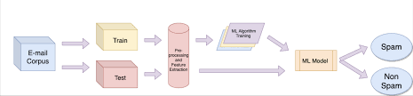
Fig: 6.1 System Architecture
The System Architecture for the Spam Detection Using Machine Learning project is designed to efficiently handle the entire process from data collection to real-time predictions via a user-friendly web interface. The system starts with the Data Collection Layer, where the dataset of email content and its corresponding labels (spam or non-spam) is either pre-loaded or uploaded by the user via the Flask Web Application. After data collection, the Data Preprocessing Layer takes over, where the raw text is cleaned by converting it to lowercase, removing punctuation, and eliminating stopwords. The cleaned data is then transformed into numerical features using TF-IDF Vectorization, which helps capture the importance of words within the emails.
In the Machine Learning Model Layer, the core component is the Multinomial Naive Bayes (MNB) model, which is trained on the preprocessed data. The model is evaluated using various metrics such as accuracy, precision, recall, F1-score, and the confusion matrix, to assess its performance in classifying emails as spam or non-spam. The trained model and the TF-IDF vectorizer are then serialized using pickle in the Model Serialization Layer, allowing them to be reused without retraining, ensuring efficiency during real-time predictions.
The Web Application Layer, powered by Flask, serves as the front-end where users can upload datasets, input email text, and receive spam classification results. This layer also provides visualizations of model performance. In the Prediction Layer, once the user provides email input, it is processed and passed to the trained model for classification, which outputs whether the email is spam or not. Lastly, the entire system can be deployed on a cloud platform like Heroku or AWS, ensuring scalability and availability for users globally.
This architecture allows for seamless interaction between the user, the data processing pipeline, and the machine learning model, offering both functionality and efficiency in detecting spam emails.

6.2 SYSTEM DESIGN :

UML DIAGRAMS :

UML stands for Unified Modeling Language. UML is a standardized general-purpose modeling language in the field of object-oriented software engineering. The standard is managed, and was created by, the Object Management Group.
The goal is for UML to become a common language for creating models of object oriented computer software. In its current form UML is comprised of two major components: a Meta-model and a notation. In the future, some form of method or process may also be added to; or associated with, UML.
The Unified Modeling Language is a standard language for specifying, Visualization, Constructing and documenting the artifacts of software system, as well as for business modeling and other non-software systems.
The UML represents a collection of best engineering practices that have proven successful in the modeling of large and complex systems.
The UML is a very important part of developing objects oriented software and the software development process. The UML uses mostly graphical notations to express the design of software projects.

GOALS:

The Primary goals in the design of the UML are as follows:
- Provide users a ready-to-use, expressive visual modeling Language so that they can develop and exchange meaningful models.
- Provide extendibility and specialization mechanisms to extend the core concepts.
- Be independent of particular programming languages and development process.
- Provide a formal basis for understanding the modeling language.
- Encourage the growth of OO tools market.
- Support higher level development concepts such as collaborations, frameworks, patterns and components.
- Integrate best practices.

6.2.1 USE CASE DIAGRAM:

A use case diagram in the Unified Modeling Language (UML) is a type of behavioral diagram defined by and created from a Use-case analysis. Its purpose is to present a graphical overview of the functionality provided by a system in terms of actors, their goals (represented as use cases), and any dependencies between those use cases. The main purpose of a use case diagram is to show what system functions are performed for which actor. Roles of the actors in the system can be depicted.
Fig : 6.2 Use case diagram

6.2.2 CLASS DIAGRAM:
In software engineering, a class diagram in the Unified Modeling Language (UML) is a type of static structure diagram that describes the structure of a system by showing the system's classes, their attributes, operations (or methods), and the relationships among the classes. It explains which class contains information.

Fig : 6.3 class diagram

6.2.3 SEQUENCE DIAGRAM:

A sequence diagram in Unified Modeling Language (UML) is a kind of interaction diagram that shows how processes operate with one another and in what order. It is a construct of a Message Sequence Chart. Sequence diagrams are sometimes called event diagrams, event scenarios, and timing diagrams.

Fig : 6.4 Sequence diagram

6.2.4 COLLABRATION DIAGRAM:

Activity diagrams are graphical representations of workflows of stepwise activities and actions with support for choice, iteration and concurrency. In the Unified Modeling Language, activity diagrams can be used to describe the business and operational step-by-step workflows of components in a system. An activity diagram shows the overall flow of control.

Fig : 6.5 Collabration diagram

6.3 Methodology
The methodology for the spam detection project begins with the identification of the problem as a binary classification task where the objective is to classify emails as either spam or non-spam. The dataset used consists of email content labeled as either spam or non-spam. The first step in the process is data collection and preprocessing, where the dataset is cleaned by removing missing values, duplicates, and irrelevant columns. Text preprocessing includes converting the text to lowercase, removing punctuation, and filtering out stop words to focus on meaningful features of the emails.
The next step involves feature extraction using TF-IDF (Term Frequency-Inverse Document Frequency). TF-IDF is applied to convert the raw text into numerical features that capture the importance of words within each email and across the entire dataset. This step helps in reducing the impact of common words like "the" or "is" that do not contribute to the classification task, while focusing on words that are unique to specific emails.
Once the data is prepared, the Multinomial Naive Bayes model is selected due to its effectiveness in handling text classification tasks. The dataset is split into training (70%) and testing (30%) sets to ensure that the model is evaluated on unseen data. The Naive Bayes model is then trained on the TF-IDF-transformed features, learning to classify the emails as spam or non-spam based on patterns in the data.
After training, the model is evaluated using various performance metrics, including accuracy, precision, recall, and F1-score, which provide insights into the model’s effectiveness. A confusion matrix is also used to visualize the performance by showing the true positives, false positives, true negatives, and false negatives. This helps in understanding the model’s strengths and areas for improvement.
To provide a user-friendly interface, a Flask web application is developed where users can upload email datasets and receive real-time spam classification predictions by entering email text. The web application also displays the model’s performance metrics, allowing users to assess the accuracy and reliability of the spam detection system.
Finally, the trained model and TF-IDF vectorizer are serialized using pickle to enable real-time predictions without the need for retraining, making the system efficient and scalable. The overall methodology ensures that the model can effectively detect spam emails and be easily accessed through a web-based interface, providing both functionality and performance evaluation.

6.4 IMPLEMENTATION:

To implement this project we have designed following Modules
- Admin Login: using this module admin can login to application by using username and password as ‘admin’ and ‘admin’
- Upload Dataset: after login admin can click on ‘Upload Dataset’ link to upload dataset to application
- Train Dataset Using Random Forest: now admin can click on this link to train random forest algorithm and this model will be applied on TEST data to calculate random forest prediction accuracy.
- Spam Detection: admin can click on this link and then enter some message and then press submit button and then Random Forest will predict that message as HAM or SPAM

CHAPTER - 7
RESULT SCREENS

7.1 HOME PAGE



7.2 LOGIN PAGE

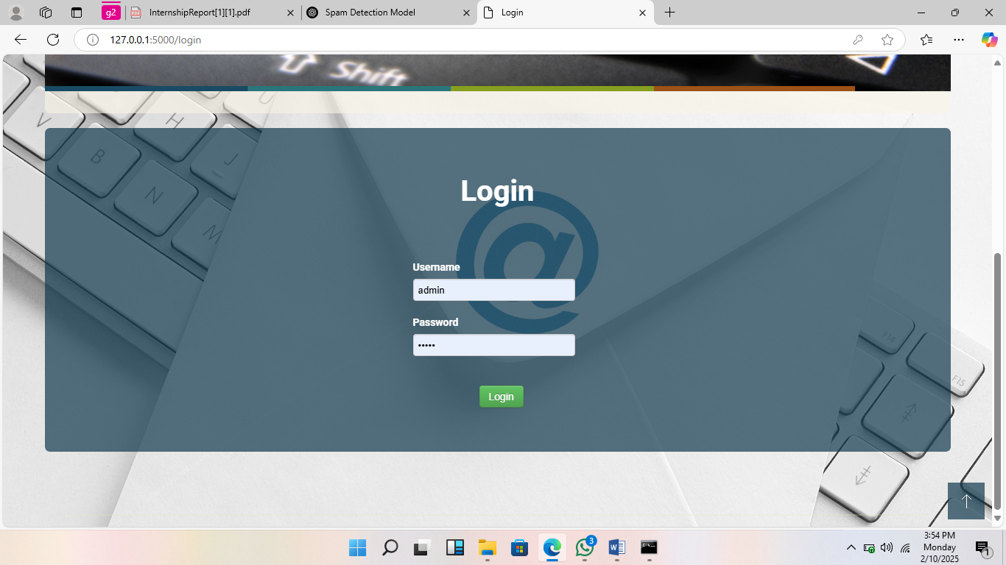
7.3 UPLOAD PAGE

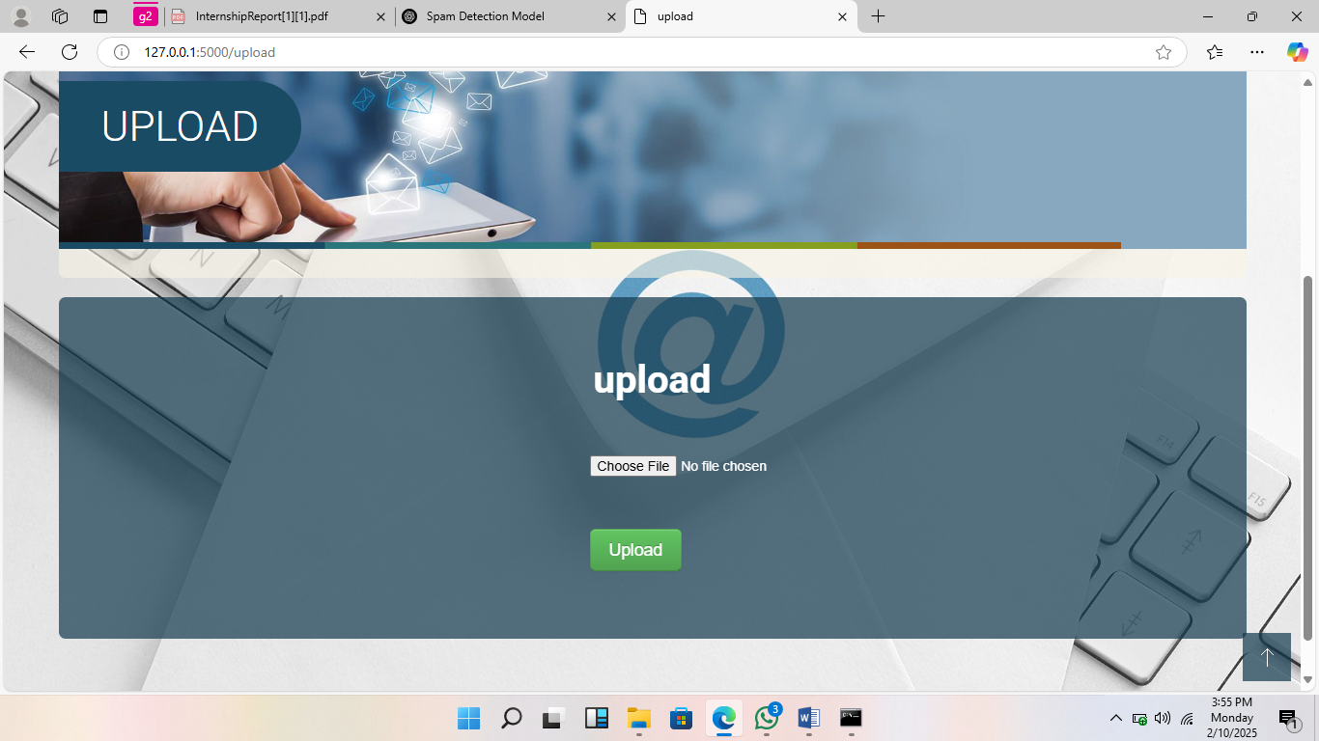

7.4 PREDICTION PAGE

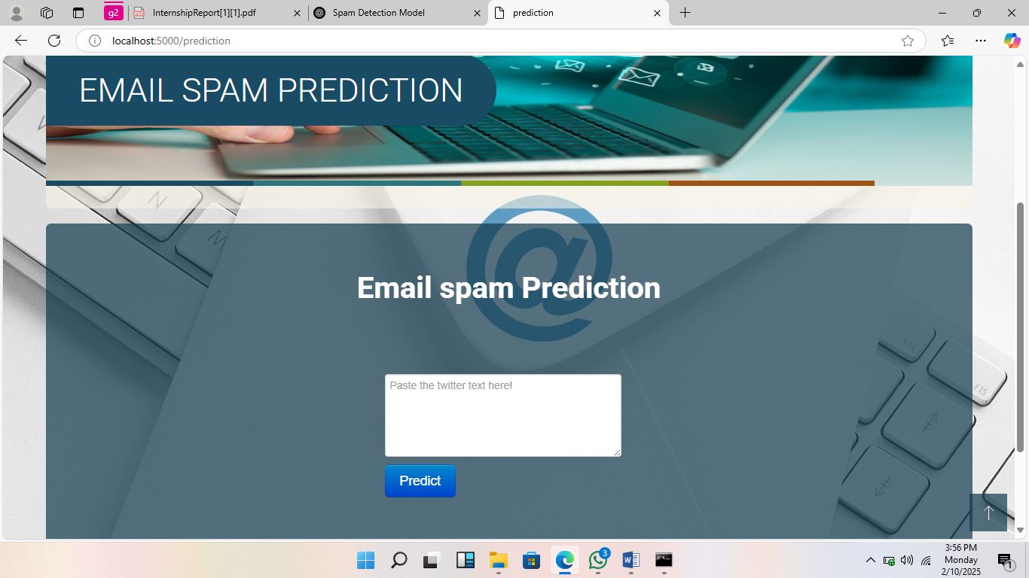

CHAPTER – 8
FUTURE APPLICATION

Future Applications of Spam Detection Using Machine Learning
The potential applications of spam detection models extend far beyond traditional email filtering. As spam becomes increasingly sophisticated, machine learning models can be adapted and enhanced for various new domains and use cases. Here are some key future applications of spam detection:

1. Social Media Spam Filtering
- With the rise of social media platforms like Facebook, Twitter, and Instagram, spam messages are also proliferating in the form of fake accounts, phishing attempts, and malicious advertisements. Machine learning-based spam detection models can be applied to these platforms to automatically filter out spam content in messages, posts, and comments, improving user experience and enhancing security.

2. SMS Spam Detection
- Spam through text messaging (SMS) is another significant concern, with unsolicited marketing messages, phishing attempts, and fraud. A spam detection model, similar to email filters, can be used to identify and block spam messages in real-time, protecting users from potential threats.

3. Phishing Website Detection
- Phishing attacks are a common method used to trick users into providing sensitive information, such as login credentials and credit card details. By analyzing website content, URLs, and metadata, machine learning models can detect suspicious or fraudulent websites in real-time, preventing users from falling victim to phishing scams.

4. Real-Time Chat and Messaging Apps
- Messaging platforms, including WhatsApp, Telegram, and Slack, are widely used for both personal and business communication. Machine learning algorithms can be deployed to detect spam and unwanted messages in real-time, ensuring that users don’t fall for scams or receive irrelevant content.

5. Automated Content Moderation in Forums and Communities
- Online forums, discussion boards, and communities are often targeted by spammers attempting to promote products or services, spread harmful content, or engage in other malicious activities. Machine learning spam filters can be integrated to automatically detect and block spam content, ensuring the quality and safety of community discussions.

6. Email Marketing Campaigns
- Spam detection models can also benefit legitimate businesses by enhancing the effectiveness of email marketing campaigns. By analyzing email content, subject lines, and engagement metrics, businesses can ensure their emails are not mistaken for spam, optimizing deliverability and customer engagement.

7. Customer Support Ticket Filtering
- Customer support platforms often receive numerous inquiries from customers, including some that may not be legitimate or relevant. Spam detection can be applied to automatically filter out unwanted or irrelevant tickets, helping support teams prioritize genuine customer queries and improve response times.

8. E-commerce and Online Marketplaces
- E-commerce platforms and online marketplaces are prime targets for spam and fraudulent activity, including fake product reviews, fraudulent transactions, and unwanted advertisements. Machine learning models can be applied to automatically detect and block spam or fraudulent actions, enhancing the trustworthiness and security of these platforms.

9. Data Privacy and Security
- Spam detection models can play a critical role in data privacy and security by identifying malicious emails, messages, or websites that may attempt to collect personal information. By detecting phishing and data-stealing attempts early, such models help prevent identity theft and data breaches.

CHAPTER -9
CONCLUSION

With this result, it can be concluded that the Multinomial Naïve Bayes gives the best outcome but has limitation due to class-conditional independence which makes the machine to misclassify some tuples. Ensemble methods on the other hand proven to be useful as they using multiple classifiers for class prediction. Nowadays, lots of emails are sent and received and it is difficult as our project is only able to test emails using a limited amount of corpus. Our project, thus spam detection is proficient of filtering mails giving to the content of the email and not according to the domain names or any other criteria. Therefore, at this it is an only limited body of the email. There is a wide possibility of improvement in our project. The subsequent improvements can be done: “Filtering of spams can be done on the basis of the trusted and verified domain names.” “The spam email classification is very significant in categorizing e-mails and to distinct e-mails that are spam or non-spam.” “This method can be used by the big body to differentiate decent mails that are only the emails they wish to obtain.”
As the internet continues to evolve, the application of spam detection technologies will become even more crucial across various platforms. Machine learning-powered spam filters can significantly improve the efficiency, security, and user experience of online systems, protecting users from evolving threats like phishing, fraud, and unwanted content. Furthermore, these models can be continuously improved as new data is collected and as the nature of spam changes, ensuring they remain effective in diverse environments.

